Analysis of WDI/HDI Dataset

Ivan Escalona (Question 5,6)
Student of Computer Science
Georgia State University
Atlanta, United States
iescalonafaria1@student.gsu.edu

Christian Moronta(Question 2)
Student of Computer Science
Georgia State University
Atlanta, United States
cmoronta1@student.gsu.edu
Oseriemen Ivbaze (Question 1)
Student of Computer Science
Georgia State University
Atlanta, United States
oivbaze1@student.gsu.edu

Bryan Davison(Question 3,4)
Student of Computer Science
Georgia State University
Atlanta, United States
bdavison7@student.gsu.edu

Introduction (Heading 1)
The economy is one of those aspects of life in which everyone has a vested interest. Having finite resources and typically more needs than resources, the economy plays a major role in both explaining as well as improving the wellbeing of individuals all the way to nations and the whole world. In addition to this, the interconnectivity of the world’s economies has brought about economic discourse that seeks to judge the economic well-being of other countries. Using the United Nations Development Programme (UNDP)’s World Development Indicators (WDI) and the World Bank’s Human Development Index (HDI), conclusions can be drawn about countries’ healthcare cost and their economic growth in relation to its HDI. This report is an in-depth analysis of those such datasets. A series of questions were chosen and answered using data analytic and machine learning libraries in python.
Question 1: Which top 5 countries that experienced the greatest economic growth?
Question 2: Which Countries Had the Highest Overall Debt?
Question 3: Comparing the domestic private health expenditures per capita and domestic general government health expenditures per capita of the 10 highest ranking HDI countries, which countries have the most expensive healthcare?
Question 4: What indicators/variables affect economic growth outside of the HDI?
Question 5: Which factors are the most important in explaining the development of countries (As per the Human Development Index)?
Question 6: Can it be accurately predicted which countries saw an increase in income inequality for 2018? (using GINI Coefficient)?
By answering these questions, we were able to discover interesting trends in our current economic landscape.

Pre-processing
Our preprocessing has been separated based on specific question type. This is due to the level of specificity of each question. Certain questions required the HDI dataset, and others not as much. Questions containing any machine learning required full control over multiple attributes in both datasets which required extensive preprocessing. Below are all of the methods used based on question.
Question 1: The WDI dataset was the only one used for this question. At a glance, the data is filled with a large amount of null values and attributes so have to really determine which ones are well suited for whatever question you’re trying to answer. After the sifting through the data, it was found that only a few attributes had reliable data for economic growth. In order to narrow it down just to the countries, the rows the first country row were omitted and only one feature was saved per file. This is mainly because the columns were separated by year, so in order to truly manipulate one attribute you needed to find a way to isolate that specific row for all of the countries.
Question 2, 5, 6: The first problem that was faced while exploring the data was its structure. The columns are reversed with the features and there are a great number of rows (422,136), but these don’t correspond to a given country-year pair for all features, but for each feature. The first thing was to transpose this and develop a structure in which the economic indicators are columns and that the rows (instances) correspond to a given country for a corresponding year.
Even before this, given the great amount of data that is present, particularly with regard to the number of features, by performing a groupby and counting for every country how many rows are there (before transposing the data frame) and then determining the number of unique features that are present in this, it was revealed that the only value is 1599. This is an assurance that there are 1599 features for all countries, even if they are null values. This is important to ensure the consistency of the Data Frame in order to perform operations on it. It is also seen that the values of all the features are numerical, this is important as the only thing to perform on them should be a normalization right before train-test splitting.
The next major challenge, as per usual, is the existence of null values in the Data Frame. The first thing was to remove all columns that had only null values. After this there was an attempt to remove all rows that had at least one null value, but this gives an empty data frame. Since there are so many features, the probabilities of having at least one null value in one of the fields is very high. One way to overcome this was to try and set a threshold to remove only columns with a high number of null values (the threshold was more than 80% null values), and then rows with more than 35% null values. This reduces the data from 1599 to 1044 columns and from 15392 to 4687 rows. This could be one approach to be used, the other one could be to leave them as is, and imputate the values by filling the null values with a given value – for instance the mean of the column. This however is not typically recommended as this might skew the data toward these values, furthermore there might be features in which the mean won't make sense and a domain expert will have to make the assessment on a case by case basis.
For example, if the GDP was to be averaged, there might be a situation in which there is a missing value for a country in which by its size, the GDP will not be nearly the world's average GDP. However to treat this will be cumbersome, time consuming, and will require a domain expert. So the risk is acknowledged, and the analysis will proceed accordingly.
The next step is to incorporate the Human Development Index by country and year into the Data Frame. The operation should be actually performed on the full Data Frame (data) since the HDI data only encompasses years 1990 onward, so 30 years after worth of information will be lost from the Data Frame. It is a safer approach to drop the null values after this merger occurs. After this, the HDI data set was merged and encoded with values 0,1,2 which according to the website tutor2u.net⁴, a low (<0.5), medium (between 0.5 and less than 0.8), high (>0.8) range can be established for the HDI, this approach was preferred since it reduces the number of labels from a continuous to only 3. The less labels the better the behavior of the model.
A Max-Min normalization (Range 0 to 1) was performed on all of the numeric features. This was preferred over a Z-Score standardization since it is hard to assess whether the data has a normal distribution or not.
Questions 3, 4: According to the World Bank, the WDI is a collection of country/region specific data on a range of topics, including but not limited to economic growth, financial sector development, and health [1]. It contains data on numerous development indicators with an observation timeline ranging from 1960 to 2019. The HDI is country specific data derived from each country’s life expectancy, years of schooling, and GNI per capita (PPP$) [2]. The observation timeline of the HDI data ranges from 1990 to 2017. The 3rd question of this research paper requires a comparison of two indicators (Domestic private health expenditures per capita and Domestic general government health expenditures per capita) from the WDI datasets with the data within the HDI dataset. However, for the year ranges [1960,2000) and [2017,2018] the data for the two key indicators of the WDI was null. So the year range of both datasets was truncated to [2000,2016] while including the 2017 HDI rankings for a more accurate analysis.
The 4th question for this research paper requires a comparison of a few WDI indicators with the highest and lowest 10 HDI rankings. Since the WDI dataset contained many economic indicators, further research was needed to figure out which specific indicators would be compared amongst the highest/lowest HDI rankings. According to both Fairmont Equities and Money Crashers, Gross Domestic Product, manufacturing/retail sales, and inflation levels as indicators of future and/or past economic performance of a country [3,4]. Furthermore, The Balance states that GDP per capita is better than regular GDP when comparing countries with various population sizes [5], which is the case for this research paper. Since the listed indicators are not directly in the indicators of the WDI dataset (excluding GDP per capita), the most similar indicators were chosen to be used, which were Inflation of Consumer Prices, Exports of Goods and Services, and Adjusted Net National Income. In a similar case for the methodology of the 3rd question, the data for these indicators were null for the year ranges [1960,1989] and the year 2018, which were removed from the data analysis.
After inspecting and exploring the data for both questions, it was revealed that there were outliers within the datasets. This led me to inspect the distribution of the data during preprocessing to determine how the data should be handled during analysis. The distributions showed that the data was skewed both left and right for many of the 10 highest/lowest ranking HDI countries. Having both issues in mind, it was decided that the data would be transformed using Scikit-Learn’s PowerTransfomer to give the data a more normal distribution and reduce the affect of outliers.

Analysis and Visualizations
Analysis was done on each preprocessed dataset based on question.
Question 1: In order to find the attributes used for economic growth, we needed to factor in the GDP Per capita of countries because it signified output. From there we have to determine what that is per capita, and factor the Purchasing power parity to compensate for the well being of the individual in a country. Finding this in the data was pretty straightforward. Making sure it was a constant dollar amount was important due to the volatile nature of nominal GDP. This allowed us to get real GDP and form a concrete analysis based on that. Once that was done The data was then split into five year intervals starting from the year 1991. This was because majority of the other years had null values, so these were the main reliable ones. Once that was done, a function was created to find the change in GDP percentage in order to rank the countries based on the highest GDP increase. Once the top five were found we discovered that China, Equatorial Guinea, Myanmar, Vietnam, and Cabo Verde were the top 5 Countries.
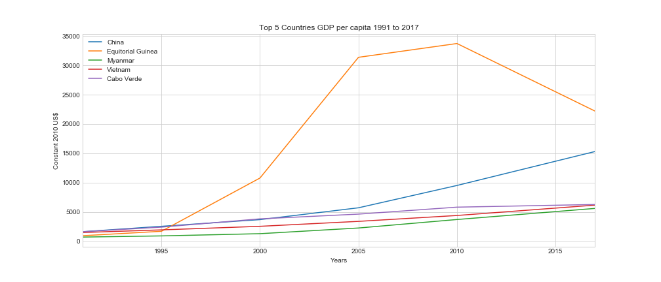

Question 2: To extract the data that was needed I had looked through the original data set and found that many of the countries were missing data related to the final year in the dataset (2018). So I chose to use data from the most recent year that I could find many had values for (2017). The feature that was related to debt was the feature called “Current account balance (BoP, current US$)”. Balance of payments is a way to describe how much a country owes. BoP is made up of three factors, but the only one that was measured in the data was the current account. This just shows the net imports and exports a country has. I then filtered the data by indexes that had the year 2017 in the index. This data frame was then sorted from greatest to least. After viewing the data, I had come up with a couple more questions that would be interesting to answer such as: of the countries with the highest debt in 2017 how much where they invested in and how much investments did they have in other countries. Gathering the data for this was done in a similar process as described above, but replacing the feature that was selected with “Foreign direct investment, net inflows (BoP, current US$)” which would show much investment by foreign countries was done in that country, and “Foreign direct investment, net outflows (BoP, current US$)” which would show how much money that given country invests in other countries. All of the data from the data frames was plotted using the matplotlib library in python.
After looking at how much foreign investment was done in the United States. I wanted to see how the 2016 election affected foreign direct investment in the US, especially with all the rhetoric about trade deficits and trade wars. I gathered the US data from 2010-2017 and plotted it in a line plot to see the changes.

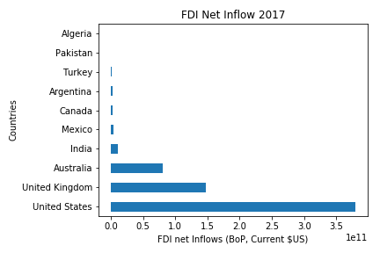
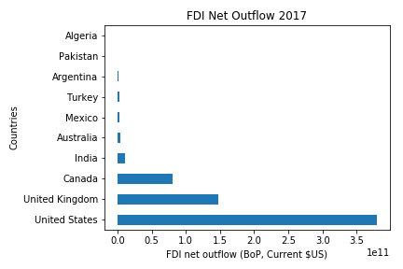
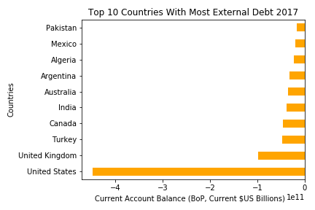
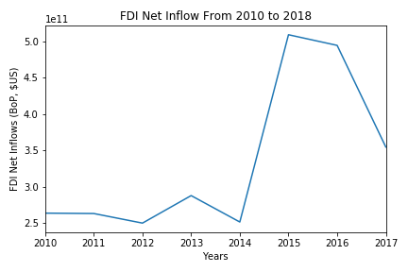

Question 3, 4: After manipulating the data to the constrains of both questions, plots were created for visual data analysis. For question 3, a scatterplot was created for the healthcare expenditures for the highest ranking and lowest ranking HDI countries. The figures are below.

For question 4 scatterplots were created to compare each of the indicators with each other for the higher and lower ranking countries. While exploring the data, regressions were created to see which indicators showed a positive relationship with each other. From there, scatterplots were created to show how the countries related to each other with these positively related indicators. The figures are below.
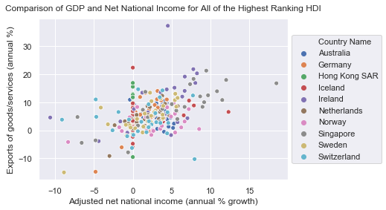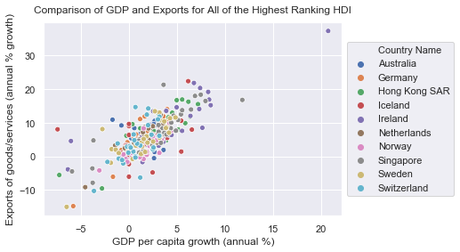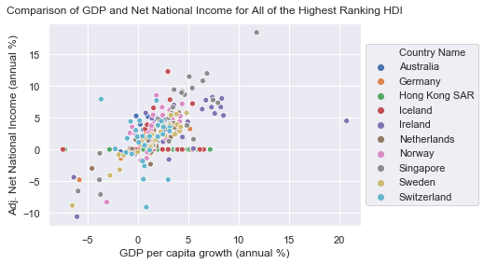

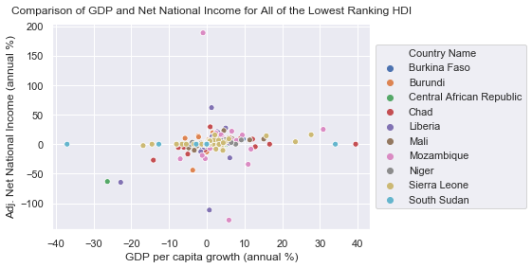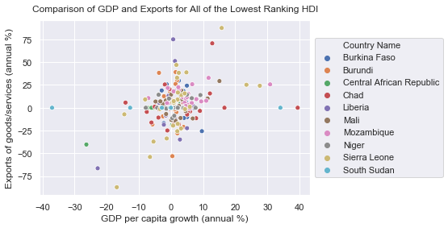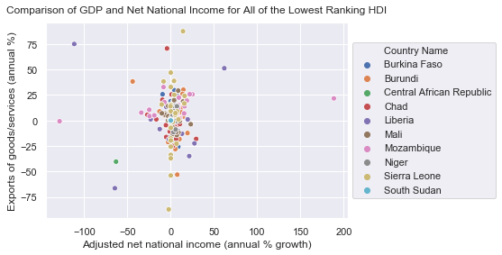

Question 5, 6: Machine Learning/Data Mining Analysis
The data shows a significant imbalance for each of the three targets (0,1,2), 61%, 20%, and 19% respectively. This suggests the need for stratified splitting. The size of the split was 90% training, 10% test.

A random forest classifier was used to model the data with the ultimate goal of extracting the quantified order of importance of each of the 1044 features entered as input in the training. The information gain criteria used were both Gini and Entropy respectively, the number of estimators were 100, and the Max. depth allowed was also changed from 1 to 15. The rest of the parameters were left as per the default ones in the module. The results are summarized on Table 1 as well as figure 1 below:

Table 1. Random Forest Classifier results
Criterion | Max. Depth | Train Score | Test Score
Gini Index | 1 | 0.759 | 0.757
Gini Index | 2 | 0.870 | 0.860
Gini Index | 3 | 0.903 | 0.895
Gini Index | 4 | 0.926 | 0.919
Gini Index | 5 | 0.951 | 0.941
Gini Index | 6 | 0.966 | 0.950
Gini Index | 7 | 0.980 | 0.967
Gini Index | 8 | 0.988 | 0.972
Gini Index | 9 | 0.991 | 0.967
Gini Index | 10 | 0.994 | 0.978
Gini Index | 11 | 0.996 | 0.976
Gini Index | 12 | 0.998 | 0.985
Gini Index | 13 | 0.999 | 0.985
Gini Index | 14 | 0.999 | 0.982
Gini Index | 15 | 0.999 | 0.985
Entropy | 1 | 0.748 | 0.751
Entropy | 2 | 0.884 | 0.880
Entropy | 3 | 0.905 | 0.897
Entropy | 4 | 0.930 | 0.928
Entropy | 5 | 0.956 | 0.945
Entropy | 6 | 0.976 | 0.956
Entropy | 7 | 0.987 | 0.969
Entropy | 8 | 0.994 | 0.974
Entropy | 9 | 0.998 | 0.978
Entropy | 10 | 1.000 | 0.980
Entropy | 11 | 1.000 | 0.982
Entropy | 12 | 1.000 | 0.980
Entropy | 13 | 1.000 | 0.982
Entropy | 14 | 1.000 | 0.982
Entropy | 15 | 1.000 | 0.980

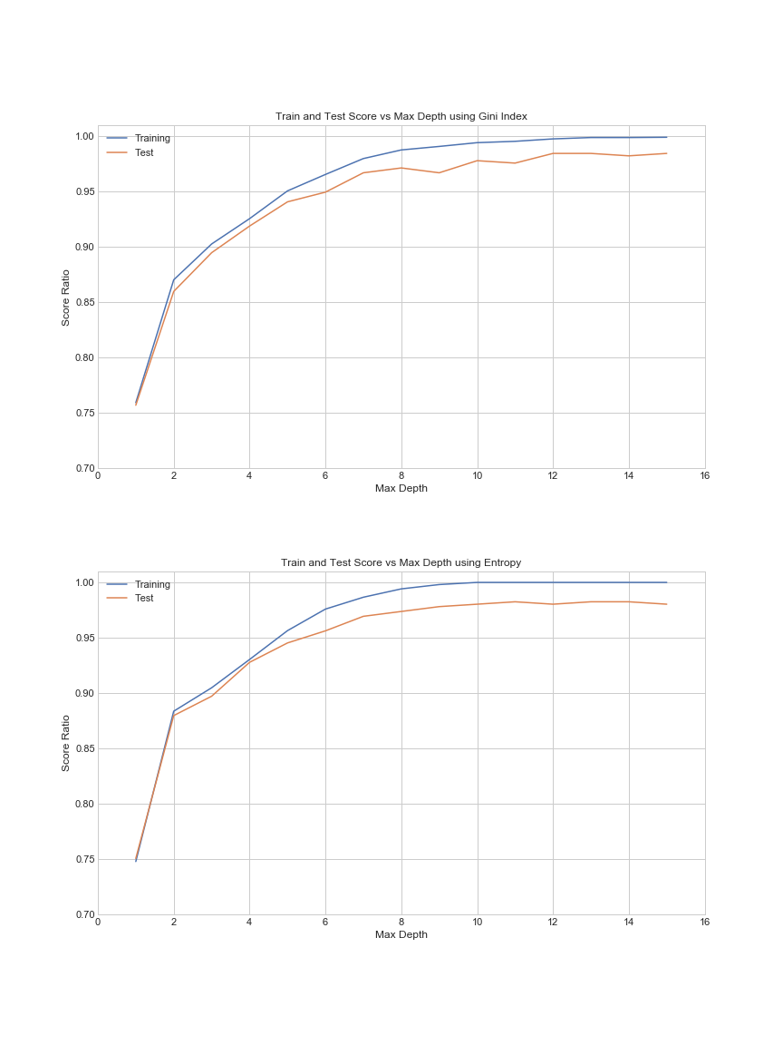
Figure 1. Train and test score vs Max. Depth. (a) Gini index (b) Entropy

The values obtained were good, certain considerations are to be made. In the case of the Gini-Random Forests there is some erratic behavior as the Max. depth increases, the best tree would be at depth 15, however this erratic behavior increases the risk of memorization of the model as opposed to generalization. It’s better to rely on the Entropy model, but at max. depth 10 the model reaches 1.00 on the training accuracy. This is a dangerous point, as the perfect match increases the risks of memorization, so the best option is to take the previous one, which still provides a test score of 0.978.

Other metrics such as the classification report and the confusion matrix are shown below in table 2 and figure 2 respectively.

Table 2. Classification report
 | f1-score | precision | recall | support
0 | 0.977 | 0.977 | 0.977 | 87
1 | 0.982 | 0.975 | 0.989 | 278
2 | 0.967 | 0.989 | 0.946 | 92
accuracy | 0.978 | 0.978 | 0.978 | 0.978
macro avg | 0.975 | 0.980 | 0.971 | 457
weighted avg | 0.978 | 0.978 | 0.978 | 457

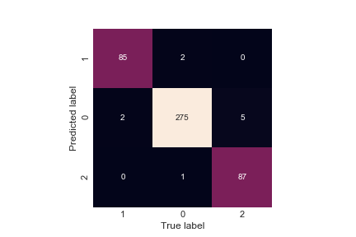
Figure 2. Confusion Matrix.

These continue to confirm good results for the model. The features were ranked in order of importance. They are too many to be shown here, but an aggregate of these is displayed on table 3.

Table 3. Feature Importance Aggregate
Number of Features | Accumulated Feature Importance
100 | 0.692
200 | 0.799
300 | 0.855
400 | 0.894
500 | 0.923
600 | 0.947
700 | 0.965
800 | 0.979
900 | 0.988
1000 | 0.995
1100 | 0.999
1200 | 1.000

A good insight comes from this table. With only 300 features, more than 85% of the data can be classified. This would allow for a dimensionality reduction of more than 5 times what the original data had. The top 10 features are shown on Table 4.

GINI Coefficient prediction

On the GINI Coefficient prediction, the first 300 features in importance from the previous model, this allows the computation to be significantly faster and focus on the more relevant features as per the model. The same split size and model parameters as with the best forest for the previous model were used.
The results are equally encouraging as the model is still showing an accuracy of more than 98%, and for specific data on 2017 it showed more than 96% accuracy.

Analysis

The top 10 important features were extracted. They only add up to 20% of the data but can provide some idea as to what further relevance or usage they can have at the time of extracting insights about the domain of nations development and income inequality. These are summarized on table 4:

Table 3. Feature Importance Aggregate
Rank | Feature name | Ratio of importance
1 | Mortality rate, neonatal (per 1,000 live births) | 0.027874266
2 | Mortality rate, adult, male (per 1,000 male adults) | 0.024642132
3 | Adjusted net national income per capita (constant 2010 US$) | 0.022163601
4 | Households and NPISHs Final consumption expenditure (current US$) | 0.020255716
5 | Lending interest rate (%) | 0.020120948
6 | Mortality rate, infant (per 1,000 live births) | 0.019636265
7 | GDP growth (annual %) | 0.018612188
8 | Access to clean fuels and technologies for cooking (% of population) | 0.018195125
9 | GNI per capita, PPP (constant 2011 international $) | 0.018028401
10 | GDP per capita (current LCU) | 0.016980809

From this it can be said that mortality plays an important role in determining the HDI, as well as some GDP, and PPP values. It can’t be said whether the relationship is direct or inverse, however this conveys more specific details as to which mortality rate is the most important, and the same can be said about the GDP and PPP indicators. The point can be made then, that in order to develop a country, special attention must be paid to the mortality rate. These are of course somewhat trivial and intuitive, as in the very same definition of HDI this is reflected.

However, an interesting feature comes ranked in 5th place, that is the “Lending interest rate (%)”, this is rarely thought of as an indication of development of a nation, yet it is in the top 10. An even more palpable one is ranked 8th “Access to clean fuels and technologies for cooking (% of population)”. It is fair to say that this would not be the first thing that comes to mind as a determining factor when classifying a nation as developed or underdeveloped.

These can become important insights if taken into consideration at the time of invest in efforts to enhance the development of nations. It could be the case that a country with low lending interest rates will have better chances to secure investments and stimulate the economy altogether rather than blindly targeting other factors.

Conclusions

Question 2: From the data and visualisations I had. The top ten countries with the most debt were (descending debt amount): United States, United Kingdom, Turkey, Canada, India, Australia, Argentina, Algeria, Mexico, and Pakistan. Of those countries, Australia, the UK, and the US had the highest amount of foreign investment into their respective countries with a factor greater than all the other countries. The countries with the most investments in foreign countries were the US, the UK, and Canada.
It seems justified to have as much debt as the countries with the highest amount of debt only when that country has high amounts of foreign direct investment inflow/outflow. Otherwise it could prove to be rather troublesome. Interestingly enough, investment in the United States dipped after the 2016 election by quite a large margin as opposed to investments made from 2014-2017. This could be due to the rhetoric on the campaign trail, but there is no way to definitively prove it. As I had come to understand, economics isn’t so black and white and it’s difficult to pinpoint one sole explanation for data.
Question 3, 4: According to the plots for question 3, of the highest ranking countries, Switzerland pays the most for healthcare, and of the lowest ranking countries, Chad pays the most for healthcare. The costs for healthcare varied more for the higher ranking countries, while the costs for the lower ranking countries are more similar to each other. According to the plots for question 4, Exports of Goods and Services, GDP per capita, and Adjusted Net National Income were indicators that positively correlated with the higher ranking HDI countries. For the lower ranking countries, these specific indicators showed a slightly positive yet very weak correlation. This suggests that these indicators can indicate economic growth in a country IF it’s HDI is already high, while on the other hand it suggests they are not the best indicators of economic growth for lower ranking countries.

